Jake Traut

3/28/16

CSCI 3656 Problem Set 9

1. 3D mesh plots, using matrix M with x, y, z value columns
   1. 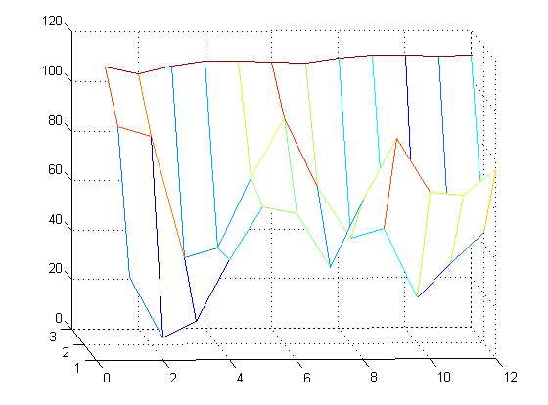Top surface mesh(M)
   2. Bottom surface mesh(M)

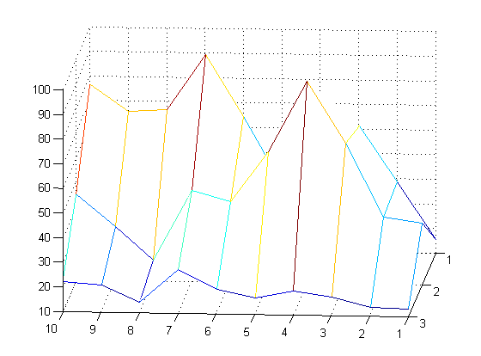

1. 3D surface interpolation

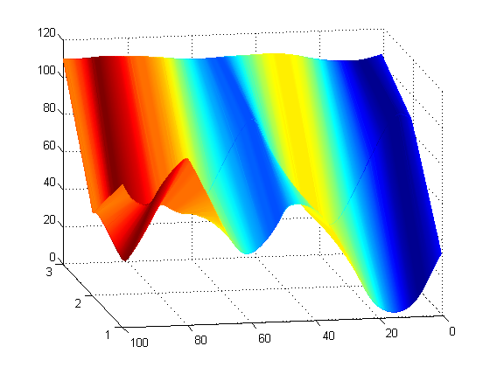

To produce this glacier figure with the given xyz points, many more points in-between had to be interpolated to create a smooth surface, rather than the linear production of solely the given points. To do this, I tried to use my previously written cubic spline function on MATLAB, but there lies a problem in that it was implemented for 2D points and not 3D. I first tried to produce the 3D interpolated points by passing the function different pairs of x y z vectors, i.e. [xS, yS] = cubic_spline(x,y) and [xS2, zS] = cubic_spline(x,z) and messed around with different pairings. But to no surprise this wasn’t producing the best, or most accurate results (close though). I wanted something better, so I started to research and attempt to add 3D implementation to my code, and while doing so came across a function that was exactly what I wanted (or was aspiring to write). So, I went on to use that spline function that can handle 3D points which gathered the points seen in the figure above. Now, as you can see, the glacier figure is actually smooth as it should be, because many points were added in-between each of the given points that fit along a certain curve. I have to give credit to the author of that function “interparc”, so thank you John D’Errico for providing the tools I was trying to create.